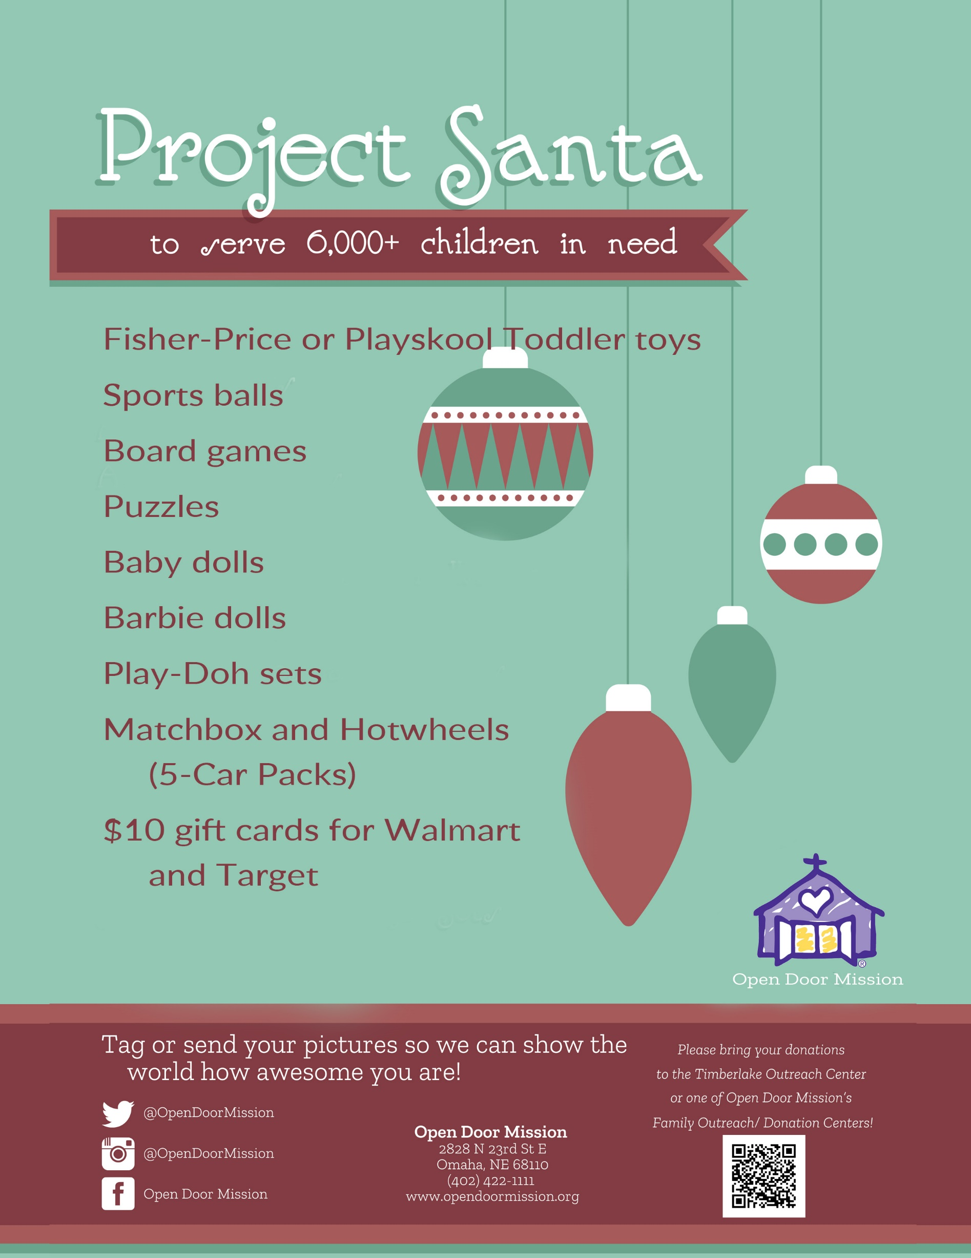
Drop Off Your Donation Items:
(Your Logo, Name, & Address or Location) on (Date/Dates)

